|  |
| --- |
|  |
| **Ramsay State School** |

2020-2023

**Student Code of Conduct**

***Every student succeeding***

***Every student succeeding is the shared vision of Queensland state schools. Our vision shapes regional and school planning to ensure every student receives the support needed to belong to the school community, engage purposefully in learning and experience academic success.***

*Queensland Department of Education*

*State Schools Strategy 2020-2024*

|  |
| --- |
| Purpose |
|  |

The school’s purpose statement indicates that a supportive school environment needs to exist to provide students with the opportunity to gain maximum benefit from their school years. A supportive school environment is one in which the rights of all members of the school community are respected and this ensures that everyone has the opportunity to achieve their goals, safely and happily.

Ramsay State School is committed to providing a safe, respectful and disciplined learning environment for all students, staff, parents and visitors.

The Ramsay State School Student Code of Conduct sets out the responsibilities and processes we use in our school to promote a productive, effective whole school approach to discipline.

Its purpose is to facilitate high standards of behaviour from all in the school community, ensuring learning and teaching in our school is prioritised, where all students are able to experience success and staff enjoy a safe workplace.

|  |
| --- |
| Contact Information |
|  |

|  |  |
| --- | --- |
| Postal address: | 173 Ramsay State School |
| Phone: | 0746309140 |
| Email: | clave1@eq.edu.au |
| School website address: | [https://ramsayss.eq.edu.au](https://ramsayss.eq.edu.au/) |
| Contact Person: | Cathy Lavelle |

|  |
| --- |
| Endorsement |
|  |

|  |  |
| --- | --- |
| Principal Name: | Cathy Lavelle |
| Principal Signature: |  |
| Date: |  |
|  |  |
| P/C President and-or School Council Chair Name: |  |
| P/C President and-or School Council Chair Signature: |  |
| Date: |  |

|  |
| --- |
| Contents |
|  |

Purpose 2

Whole School Approach to Discipline 4

Consideration of Individual Circumstances 4

Differentiated and Explicit Teaching 4

Focussed Teaching 5

Intensive Teaching 5

Disciplinary Consequences 6

School Policies 7

Temporary removal of student property 7

Use of mobile phones and other devices by students 9

Preventing and responding to bullying 9

Appropriate use of social media 14

Restrictive Practices 16

Critical Incidents 17

|  |
| --- |
| Whole School Approach to Discipline |
|  |

At Ramsay State School we believe in a positive approach to managing behaviour using the Positive Behaviour for Learning approach. We encourage our students to be responsible for their own learning and behaviour, supported by appropriate modelling and teaching by staff and the school community. Home, school and community have complementary roles to play in setting and maintaining an acceptable standard of student behaviour. They have a joint responsibility to lead, guide and influence students to accept and observe that standard. This plan, integrated with curriculum and management strategies, will assist in developing a strong sense of pride, positive attitudes and future direction of Ramsay State School.

**Consideration of Individual Circumstances**

Individual management plans will be developed for those students who exhibit challenging behaviour, or with ongoing behavioural or developmental needs which require individual support to define desired behavioural outcomes. These students have not responded to the behavioural management strategies operating in the school, with potentially damaging effects on other students and staff and seem to be destined for suspension or exclusion. The Individual Management Plan is a management and teaching process rather than a disciplinary process as discipline options may have been exhausted. To ensure clear expectations of our standards of behaviour for all students are set and agreed to by students, staff and parents, a behaviour contract system has been set up in negotiation with staff, students and parents. Our contracts operate at two levels: School Contract; Classroom Contract. If a behavioural contract is required either at classroom level or school level, it will be negotiated with student and parents.

Our teachers are also obliged by law to respect and protect the privacy of individual students, so while we understand the interest of other students, staff and parents to know what punishment another student might have received, we will not disclose or discuss this information with anyone but the student’s family. This applies even if the behavioural incident, such as bullying, involves your child. You can be assured that school staff take all matters, such as bullying, very seriously and will address them appropriately. We expect that parents and students will respect the privacy of other students and families.

**Differentiated and Explicit Teaching**

Ramsay State School is a disciplined school environment that provides differentiated teaching to respond to the learning needs of all students. This involves teaching expected behaviours and providing opportunities for students to practise these behaviours. Teachers reinforce expected behaviours, provide feedback and correction, and opportunities for practise.

Teachers at Ramsay State School vary what students are taught, how they are taught and how students can demonstrate what they know as part of this differentiated approach to behaviour. These decisions about differentiation are made in response to data and day-to-day monitoring that indicates the behavioural learning needs of students. This enables our teachers to purposefully plan a variety of ways to engage students; assist them to achieve the expected learning; and to demonstrate their learning.

There are three main layers to differentiation, as illustrated in the diagram below. This model is the same used for academic and pedagogical differentiation.

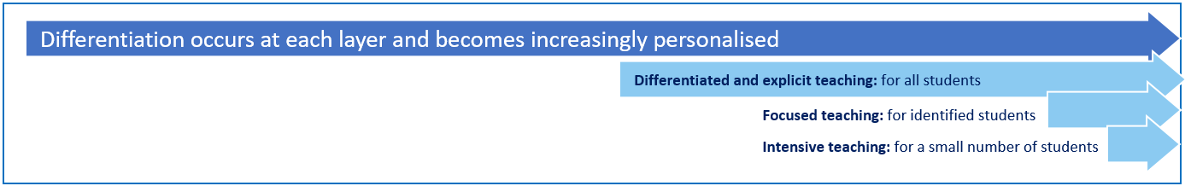

**Focused Teaching**

Each year a small number of students are identified through data as needing a little bit extra in the way of targeted behavioural support. In most cases the problem behaviours of these students may not be immediately regarded as severe, but the frequency of their behaviours may put these students’ learning and social success at risk if not addressed in a timely manner. A variety of strategies and adjustments will be implemented to assist these students to maintain expected behaviour. Students whose behaviour does not improve or whose previous behaviour indicates a need for specialised intervention, are provided with intensive behaviour support.

**Intensive Teaching**

Ramsay State School is committed to educating all students, including those with the highest behavioural support needs. We recognise that students with highly complex and challenging behaviours need comprehensive systems of support.

Our Behaviour team:

• works together to develop appropriate behaviour support strategies

• monitors the impact of support for individual students through continuous data collection

• makes adjustments as required for the student, and

• works with all staff to achieve continuity and consistency.

Following referral, the principal contacts parents and any relevant staff members to begin the assessment and support process. In some cases the support team also includes individuals from other agencies already working with the student and their family, a representative from the school’s administration and district-based behavioural support staff.

|  |
| --- |
| Disciplinary Consequences |
|  |

**Re-directing low-level and infrequent problem behaviour**

- When students exhibit low-level and infrequent problem behaviour, the first response of school staff members is to remind the student of expected school behaviour, then ask them to change their behaviour so that it aligns with our school’s expectations.

- Use the redirection prompt card below:-

1. **Prompt** – signal the misbehaviour
2. **Redirect** – restate using matrix behaviour words
3. **Reteach** – tell, show, practise
4. **Provide choices**
5. **Conference** with the student
6. Short term removal from the activity or time away

**Minor problem behaviours may result in the following consequences:**

• a minor consequence logically connected to the problem behaviour, such as complete removal from an activity or event for a specified period of time, partial removal (time away), individual meeting with the student, apology, restitution or using playtime for work completion.

• The staff member takes the student aside and:

1. names the behaviour that student is displaying,

2. asks student to name expected school behaviour,

3. states and explains expected school behaviour and allows student to demonstrate and practise

4. gives positive verbal acknowledgement for demonstrated expected school behaviour

**Consequences for major behaviours may include:**

• Time in office

• Removal from class and play routine

• Alternate programs

• Loss of privileges including withdrawal from excursions, school activities and special events. Duration of loss is at the discretion of the principal and will be determined by the behaviours.

• Restitution

• Referral to Guidance Officer and/or the Intensive Support Behaviour Team.

• Internal suspension –child is withdrawn from instruction and the playground and given work to do isolated from other students.

• Suspension

• Cancellation of enrolment

|  |
| --- |
| School Policies |
|  |

**Temporary removal of student property**

The removal of any property in a student’s possession may be necessary to promote the caring, safe and supportive learning environment of the school, to maintain and foster mutual respect between all state school staff and students. The **Temporary removal of student property by school staff procedure** outlines the processes, conditions and responsibilities for state school principals and school staff when temporarily removing student property.

In determining what constitutes a reasonable time to retain student property, the principal or state school staff will consider:

* the condition, nature or value of the property
* the circumstances in which the property was removed
* the safety of the student from whom the property was removed, other students or staff members
* good management, administration and control of the school.

The Principal or staff determine when the temporarily removed student property can be returned, unless the property has been handed to the Queensland Police Service.

The following items are explicitly prohibited at Ramsay State School and will be removed if found in a student’s possession:

* illegal items or weapons, imitation guns or weapons
* potentially dangerous items (e.g. blades, rope)
* drugs** (including tobacco)
* alcohol
* aerosol deodorants or cans (including spray paint)
* explosives (e.g. fireworks, flares, sparklers)
* flammable solids or liquids (e.g. fire starters, mothballs, lighters)
* poisons (e.g. weed killer, insecticides)
* inappropriate or offensive material (e.g. racist literature, pornography, extremist propaganda).

** The administration of medications to students by school staff is only considered when a prescribing health practitioner has determined that it is necessary or when there is no other alternative in relation to the treatment of a specific health need. Schools require medical authorisation to administer any medication to students (**including over-the-counter medications such as paracetamol or alternative medicines**).

**Responsibilities**

**State school staff** at Ramsay State School:

* do not require the student’s consent to search school property such as lockers, desks or laptops that are supplied to the student through the school;
* may seize a student’s bag where there is suspicion that the student has a dangerous item (for example, a knife) in their school bag, prior to seeking consent to search from a parent or calling the police;
* consent from the student or parent is required to examine or otherwise deal with the temporarily removed student property. For example, staff who temporarily remove a mobile phone from a student are not authorised to unlock the phone or to read, copy or delete messages stored on the phone;
* there may, however, be emergency circumstances where it is necessary to search a student’s property without the student’s consent or the consent of the student’s parents (e.g. to access an EpiPen for an anaphylactic emergency);
* consent from the student or parent is required to search the person of a student (e.g. pockets or shoes). If consent is not provided and a search is considered necessary, the police and the student’s parents should be called to make such a determination.

**Parents** of students at Ramsay State School

* ensure your children do not bring property onto schools grounds or other settings used by the school (e.g. camp, sporting venues) that:
  + is prohibited according to the Ramsay State School Student Code of Conduct
  + is illegal
  + puts the safety or wellbeing of others at risk
  + does not preserve a caring, safe, supportive or productive learning environment
  + does not maintain and foster mutual respect;
* collect temporarily removed student property as soon as possible after they have been notified by the Principal or state school staff that the property is available for collection.

**Students** of Ramsay State School

* do not bring property onto school grounds or other settings used by the school (e.g. camp, sporting venues) that:
  + is prohibited according to the Ramsay State School Code of Conduct
  + is illegal
  + puts the safety or wellbeing of others at risk
  + does not preserve a caring, safe, supportive or productive learning environment
  + does not maintain and foster mutual respect;
* collect their property as soon as possible when advised by the Principal or state school staff it is available for collection.

**Use of mobile phones and other devices by students**

Students are not to bring personal technology devices to school because of the potential for theft, distraction and disruption associated with them and the parental concern that unsupervised inappropriate sharing of content between students may occur. However, if it is necessary that students devices are brought to school, they must be handed to staff for safe storage from the time of arrival at school until the end of the school day. These devices are brought to school at the owner’s risk. The school will not be responsible for personal technology devices which are lost / stolen, and staff will not conduct investigations, searches etc. to locate personal technology devices which are lost / stolen. Visitors to the school, including parents, are not to allow students to use their devices unsupervised for the above reasons.

**Preventing and responding to bullying**

Our staff know student learning is optimised when they feel connected to others and experience safe and trusting relationships. Students who feel secure are more likely to be active participants in their learning and to achieve better physical, emotional, social and educational outcomes. Teachers who feel valued and supported are more likely to engage positively with students and build stronger connections within the school community. Parents who are positively engaged with their child’s education leads to improved student self-esteem, attendance and behaviour at school. Enhancing the wellbeing of students and their educators delivers overall long-term social, health and economic benefits to the Australian community.

Framework:



1. **Leadership**

Principals and school leaders playing an active role in building a positive learning environment where the whole school community feels included, connected, safe and respected.

1. **Inclusion**

All members of the school community actively participating in building a welcoming school culture that values diversity, and fosters positive, respectful relationships.

1. **Student voice**

Students actively participate in their own learning and wellbeing, feel connected and use their social and emotional skills to be respectful, resilient and safe.

1. **Partnerships**

Families and communities collaborating as partners with the school to support student learning, safety and wellbeing.

1. **Support**

School staff, students and families sharing and cultivating an understanding of wellbeing and positive behaviour and how this supports effective teaching and learning.

**Bullying**

The agreed national definition for Australian schools describes bullying as

* ongoing and deliberate misuse of power in relationships through repeated verbal, physical and/or social behaviour that intends to cause physical, social and/or psychological harm;
* involving an individual or a group misusing their power, or perceived power, over one or more persons who feel unable to stop it from happening;
* happening in person or online, via various digital platforms and devices and it can be obvious (overt) or hidden (covert). Bullying behaviour is repeated, or has the potential to be repeated, over time (for example, through sharing of digital records);
* having immediate, medium and long-term effects on those involved, including bystanders. Single incidents and conflict or fights between equals, whether in person or online, are not defined as bullying.

Behaviours that do not constitute bullying include:

* mutual arguments and disagreements (where there is no power imbalance)
* not liking someone or a single act of social rejection
* one-off acts of meanness or spite
* isolated incidents of aggression, intimidation or violence.

However, these conflicts are still considered serious and need to be addressed and resolved. At Ramsay State School our staff will work to quickly respond to any matters raised of this nature in collaboration with students and parents.

The following flowchart explains the actions Ramsay State School teachers will take when they receive a report about student bullying, including bullying which may have occurred online or outside of the school setting. Please note that the indicative timeframes will vary depending on the professional judgment of teachers who receive the bullying complaint and their assessment of immediate risk to student/s.

**Bullying response flowchart for teachers**

**Key contacts for students and parents to report bullying:**

**Prep to Year 6** – Class teacher, staff member or Principal

* Provide a safe, quiet space to talk
* Reassure the student that you will listen to them
* Let them share their experience and feelings without interruption
* If you hold immediate concerns for the student's safety, let the student know how you will address these. Immediate in this circumstance is where the staff member believes the student is likely to experience harm (from others or self) within the next 24 hours
* Continue to check in with student on regular basis until concerns have been mitigated
* Record notes of follow-up meetings in OneSchool
* Refer matter to specialist staff within 48 hours if problems escalate
* Look for opportunities to improve school wellbeing for all students
* Evaluate the information to determine if bullying has occurred or if another disciplinary matter is at issue
* Make a time to meet with the student to discuss next steps
* Ask the student what they believe will help address the situation
* Provide the student and parent with information about student support network
* Agree to a plan of action and timeline for the student, parent and yourself
* Ask the student for examples they have of the alleged bullying (e.g. hand written notes or screenshots)
* Write a record of your communication with the student
* Check back with the student to ensure you have the facts correct
* Enter the record in OneSchool
* Notify parent/s that the issue of concern is being investigated
* Gather additional information from other students, staff or family
* Review any previous reports or records for students involved
* Make sure you can answer who, what, where, when and how
* Clarify information with student and check on their wellbeing
* Document the plan of action in OneSchool
* Complete all actions agreed with student and parent within agreed timeframes
* Monitor the student and check in regularly on their wellbeing
* Seek assistance from student support network if needed
* Meet with the student to review situation
* Discuss what has changed, improved or worsened
* Explore other options for strengthening student wellbeing or safety
* Report back to parent
* Record outcomes in OneSchool

**Cyberbullying**

Cyberbullying is treated at Ramsay State School with the same level of seriousness as in-person bullying. The major difference with cyberbullying however, is that unlike in-person bulling, cyberbullying follows students into their community, their homes and their bedrooms, giving them no opportunity to escape the harassment or abuse during the evening, weekends or holidays.

In the first instance, students or parents who wish to make a report about cyberbullying should approach the regular class teacher.

It is important for students, parents and staff to know that state school principals have the authority to take disciplinary action to address student behaviours that occur outside of school hours or school grounds. This includes cyberbullying. Parents and students who have concerns about cyberbullying incidents occurring during school holidays should immediately seek assistance through the [Office of the e-Safety Commissioner](https://www.esafety.gov.au/) or the Queensland Police Service.

Students enrolled at Ramsay State School may face in-school disciplinary action, such as detention or removing of privileges, or more serious consequences such as suspension or exclusion from school for engaging in behaviour that adversely affects, or is likely to adversely affect, other students or the good order and management of the school. This includes behaviour such as cyberbullying which occurs outside of school hours or settings, for example on the weekend or during school holidays. It also applies to inappropriate online behaviour of enrolled students that is directed towards other community members or students from other school sites.

Parents or other stakeholders who engage in inappropriate online behaviour towards students, staff or other parents may be referred to the Office of the e-Safety Commissioner and/or the Queensland Police Service. State school staff will be referred for investigation to the Integrity and Employee Relations team in the Department of Education

**Cyberbullying response flowchart for school staff**

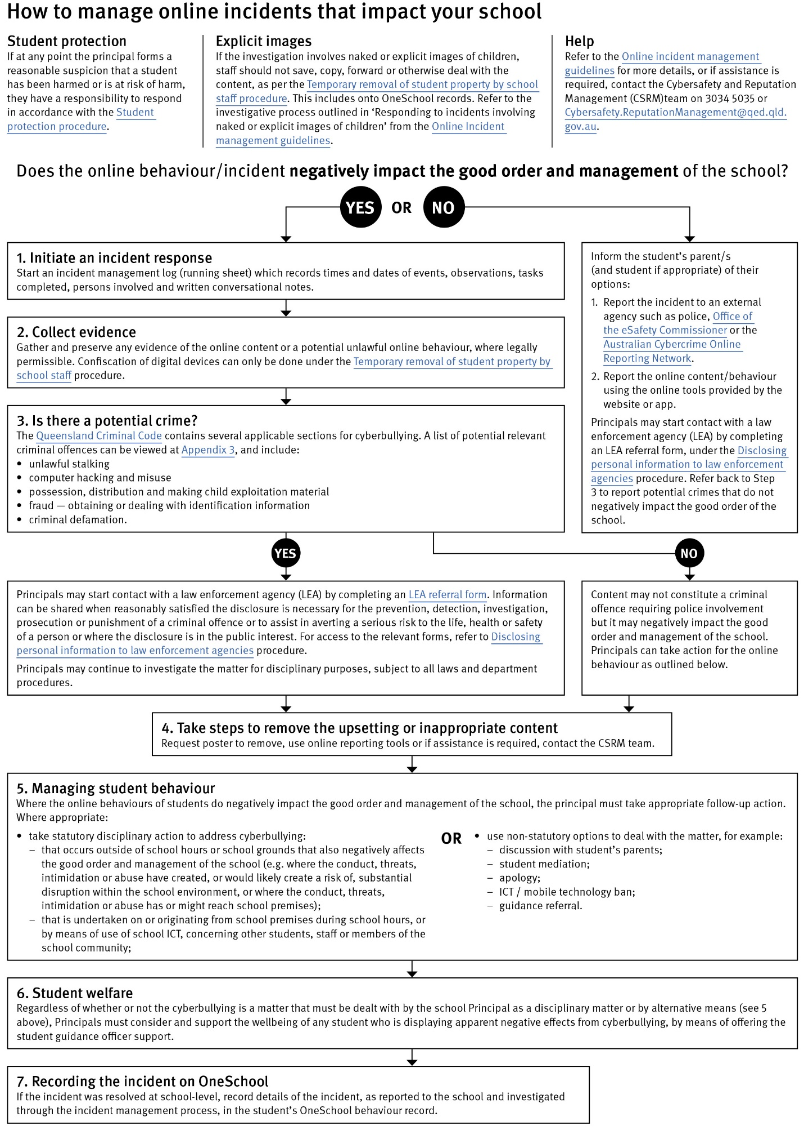

**Appropriate use of social media**

While technologies provide platforms for sharing ideas, they also have the potential to cause pain and suffering to individuals, groups or even whole communities.

It’s important to remember that sometimes negative comments posted about the school community have a greater impact than expected. This guide offers some information about how to use social media in relation to comments or posts about the school community. Reputations of students, teachers, schools, principals and even parents can be permanently damaged — and in some cases, serious instances of inappropriate online behaviour are dealt with by police and the court system.

Being aware of a few simple strategies can help keep the use of social media positive and constructive:

* Before you post something online, ask yourself if the community or individual really need to know. Is it factual, relevant, positive and helpful?
* Remember that what you post online is a direct reflection of who you are. People will potentially form lasting opinions of you based on what you post online.
* Be a good role model. If things get heated online consider logging out and taking a few moments to relax and think. Hasty, emotive responses could inflame situations unnecessarily.
* Be mindful when commenting, try to keep general and avoid posting anything that could identify individuals.
* A few years ago parents may have discussed concerns or issues with their friends at the school gate and the audience was obvious. Today with the use of social media, online discussions between you and your close friends can very quickly be shared with a much wider audience, potentially far larger than intended.
* Taking a few moments to think about the content you are about to post could save upset, embarrassment, and possible legal action.
* As a parent you have a role in supervising and regulating your child’s online activities at home and its impact on the reputation and privacy of others. Parents are their child’s first teachers — so they will learn online behaviours from you.

**Is it appropriate to comment or post about schools, staff or students?**

Parental and community feedback is important for schools and the department. If you have a compliment, complaint or enquiry about an issue at school, the best approach is to speak directly to the school about the matter, rather than discussing it in a public forum.

While many schools use social media to update parents of school notices, the department prefers that parents contact schools directly with a compliment, complaint or enquiry due to privacy considerations. Imagine if your doctor, accountant or banking institution tried to contact you to discuss important matters via Facebook.

If you have raised an issue with a school or know that another person has, refrain from discussing those details on social media, particularly the names of anyone involved.

Keep comments calm and polite, just as you would over the telephone or by email. If you encounter negative or derogatory content online which involves the school, hinders a child’s learning and/or affects the school community at large, contact the school principal.

**Possible civil or criminal ramifications of online commentary**

A serious instance of inappropriate online behaviour may constitute a criminal offence and become a police matter. For example, online content may substantiate the offence of ‘using a carriage service to menace, harass or cause offence’ (Criminal Code Act 1995 (Cth) s. 474.17). School staff may contact their union or obtain personal legal advice if they feel that online content seriously impacts their reputation. Defamatory online content may give rise to litigation under the Defamation Act 2005 (Qld).

**What about other people’s privacy?**

If you upload photos of your children, be mindful of who might be in the background. You might be happy to share your child’s successes with your friends and family via social media, but some parents are not. If you are tagging or naming students, consider that other parents may not want their child’s name attached to images online.

**What if I encounter problem content?**

Taking the following steps may help resolve the issue in a constructive way:

* refrain from responding
* take a screen capture or print a copy of the concerning online content
* if you consider problem content to be explicit, pornographic or exploitative of minors, you should keep a record of the URL of the page containing that content but NOT print or share it. The URL can be provided to the school principal, or police, as needed for escalation of serious concerns
* block the offending user
* report the content to the social media provider.

|  |
| --- |
| Restrictive Practices |
|  |

School staff at Ramsay State School need to respond to student behaviour that presents a risk of physical harm to the student themselves or others. It is anticipated that most instances of risky behaviour can be de-escalated and resolved quickly. On some rarer occasions, a student’s behaviour may continue to escalate and staff need to engage immediately with positive and proactive strategies aimed at supporting the student to manage their emotional arousal and behaviour.

In some very rare situations, where there is immediate risk of physical harm to the student or other people, and when all other alternative strategies have failed to reduce the risk, it may be necessary for staff to use restrictive practices.

The use of restrictive practices will always be as a last resort, when there is no other available option for reducing immediate risk to the student, staff or other people. Restrictive practices are not used for punishment or as a disciplinary measure.

The department’s **Restrictive practices procedure** is written with consideration for the protection of everyone’s human rights, health, safety and welfare. There are six fundamental principles:

1. Regard to the human rights of those students
2. Safeguards students, staff and others from harm
3. Ensures transparency and accountability
4. Places importance on communication and consultation with parents and carers
5. Maximises the opportunity for positive outcomes, and
6. Aims to reduce or eliminate the use of restrictive practices.

Very rarely restrictive practices will be planned and staff will employ, when necessary, pre-arranged strategies and methods (of physical restraint/ mechanical restraint/ clinical holding) which are based upon behaviour risk assessment or clinical health need and are recorded in advance. The use of planned strategies will only be where there is foreseeable immediate risk consistent with the **Restrictive practices procedure**.

Seclusion will not be used as a planned response and will only be used in serious circumstances for managing an unforeseeable situation in an emergency. It will be used for the shortest time possible and in a safe area that presents no additional foreseeable risk to the student. In such emergencies, a staff member will observe the student at all times and seclusion will cease as soon as possible.

Following the use of any restrictive practice, a focused review will help staff to understand how they responded to the risk in any incident that involved the use of a restrictive practice. Staff will consider whether there are other options for managing a similar situation in the future. This strategy works well for reducing the use of restrictive practices.

All incidents of restrictive practices will be recorded and reported in line with departmental procedures.

|  |
| --- |
| Critical Incidents |
|  |

An **emergency situation or critical incident** is defined as an occurrence that is sudden, urgent, and usually unexpected, or an occasion requiring immediate action.

Basic defusing strategies

*Avoid escalating the problem behaviour*

(Avoid shouting, cornering the student, moving into the student’s space, touching or grabbing the student, sudden responses, sarcasm, becoming defensive, communicating anger and frustration through body language).

*Maintain calmness, respect and detachment*

(Model the behaviour you want students to adopt, stay calm and controlled, use a serious measured tone, choose your language carefully, avoid humiliating the student, be matter of fact and avoid responding emotionally).

*Approach the student in a non-threatening manner*

(Move slowly and deliberately toward the problem situation, speak privately to the student/s where possible, speak calmly and respectfully, minimise body language, keep a reasonable distance, establish eye level position, be brief, stay with the agenda, acknowledge cooperation, withdraw if the situation escalates).

*Follow through*

(If the student starts displaying the appropriate behaviour briefly acknowledge their choice and re-direct other students’ attention towards their usual work/activity. If the student continues with the problem behaviour then remind them of the expected school behaviour and identify consequences of continued unacceptable behaviour).

*Debrief*

(Help the student to identify the sequence of events that led to the unacceptable behaviour, pinpoint decision moments during the sequence of events, evaluate decisions made, and identify acceptable decision options for future situations).